The work in the lab can be divided into the following three sub-tasks:

1. Understanding the IC(L293D) and connecting the IC together with the motor and Arduino Mega.

2. Coding the Arduino for basic control of the motor and then applying the PID algorithm.

3. Debugging the PID parameters to get the optimal results.

## The Circuit

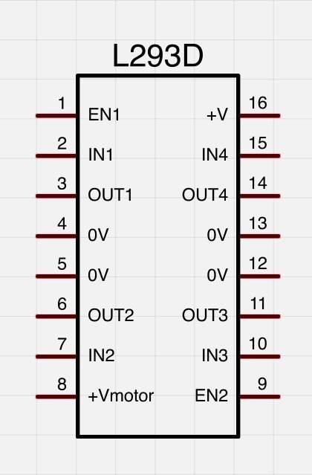The pinout of the IC used i.e., L293D, is shown alongside. The pin functions can be

understood as follows:

EN1/EN2: Pulled up for enabling IN1/2(OUT1/2) and IN3/4(OUT3/4) respectively

INx: Pulled up for making OUTx to +Vmotor

+V: Connected to 5V as a IC Power supply

+Vmotor: Connected to a 12V-15V source. Used for providing motor voltage.

Arduino Mega is a micro controller board. It is used for reading the sensor values and then applying proper PWM voltages to the motor. The processing for finding the appropriate PWM signal is also done on the same board.

We used the PWM pins 2 and 3 for generated the required output and the analog pin A0 for reading the sensor values. The coding was done on the Arduino IDE and the code was then loaded on the board using the same IDE.

## The Code

The code written onto the microprocessor can be understood by the following flowchart:



For reference the final code is also provided at the end of the report.

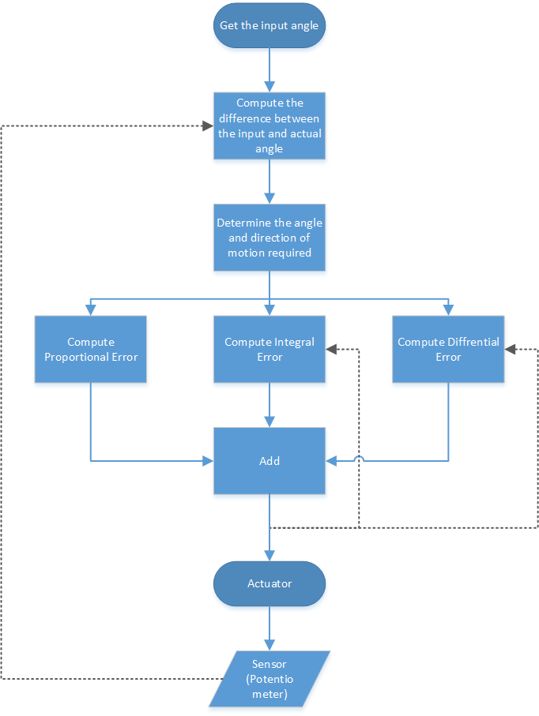The PID algorithm used in the control processing can be understood as follows:

**Proportional Error(P)**: Accounts for the present value of the error. Higher current error => Higher P

**Integral Error(I)**: Accounts for higher precision of the error. Accumulates the error until the goal is not reached

**Differential Error(D)**: Takes care of any sudden change in error. Ensures smooth transition

## The Trial and Error Method

For finding the optimal PID parameters, we ran the code many times with various parameters to get an approximation of the values of the parameters for the given system.

Final Values of Coefficients

|  |  |  |
| --- | --- | --- |
| $$K_{p}$$ | $$K_{I}$$ | $$K_{D}$$ |
| 25 | 0.001 | 5 |

|  |  |
| --- | --- |
| Rise Time | 0.443s |
| Overshoot | $6^{o}$ |
| Settling Time | 0.7s |

Input Data:

|  |  |
| --- | --- |
| Time(ms) | Angle |
| 1 | 358 |
| 1 | 358 |
| 1 | 358 |
| 2 | 358 |
| 2 | 358 |
| 3 | 358 |
| 3 | 358 |
| 4 | 358 |
| 4 | 357 |
| 8 | 358 |
| 14 | 357 |
| 22 | 356 |
| 29 | 355 |
| 37 | 353 |
| 44 | 350 |
| 51 | 348 |
| 58 | 345 |
| 65 | 343 |
| 72 | 339 |
| 80 | 337 |
| 88 | 334 |
| 95 | 331 |
| 102 | 328 |
| 110 | 325 |
| 118 | 322 |
| 127 | 319 |
| 135 | 316 |
| 143 | 313 |
| 152 | 310 |
| 160 | 306 |
| 169 | 303 |
| 177 | 299 |
| 185 | 297 |
| 193 | 293 |
| 201 | 290 |
| 210 | 287 |
| 219 | 284 |
| 227 | 280 |
| 235 | 277 |
| 243 | 273 |
| 252 | 270 |
| 260 | 267 |
| 268 | 264 |
| 276 | 261 |
| 285 | 258 |
| 294 | 255 |
| 302 | 251 |
| 310 | 248 |
| 318 | 245 |
| 326 | 242 |
| 335 | 239 |
| 343 | 235 |
| 352 | 232 |
| 360 | 229 |
| 368 | 226 |
| 377 | 222 |
| 385 | 220 |
| 393 | 216 |
| 401 | 213 |
| 409 | 210 |
| 418 | 207 |
| 427 | 203 |
| 435 | 200 |
| 443 | 196 |
| 451 | 194 |
| 459 | 190 |
| 468 | 188 |
| 476 | 184 |
| 485 | 183 |
| 493 | 178 |
| 501 | 177 |
| 510 | 176 |
| 518 | 175 |
| 526 | 174 |
| 534 | 174 |
| 542 | 174 |
| 552 | 174 |
| 560 | 175 |
| 568 | 175 |
| 576 | 176 |
| 584 | 176 |
| 593 | 178 |
| 601 | 179 |
| 609 | 181 |
| 618 | 182 |
| 626 | 180 |
| 635 | 182 |
| 643 | 182 |
| 651 | 182 |
| 659 | 182 |
| 667 | 182 |
| 676 | 182 |
| 685 | 182 |
| 693 | 180 |
| 701 | 181 |
| 709 | 181 |
| 717 | 181 |
| 726 | 181 |
| 734 | 181 |
| 742 | 181 |
| 751 | 181 |
| 759 | 178 |
| 768 | 181 |
| 776 | 181 |
| 784 | 181 |
| 792 | 181 |
| 800 | 181 |
| 809 | 181 |
| 818 | 181 |
| 826 | 179 |
| 834 | 181 |
| 842 | 181 |
| 851 | 181 |
| 859 | 181 |
| 867 | 181 |
| 875 | 181 |
| 884 | 181 |
| 893 | 179 |
| 901 | 181 |
| 909 | 181 |
| 917 | 181 |
| 925 | 181 |
| 934 | 181 |
| 942 | 181 |
| 951 | 180 |
| 959 | 179 |
| 967 | 181 |
| 976 | 181 |
| 984 | 181 |
| 992 | 181 |
| 1000 | 181 |
| 1009 | 181 |
| 1020 | 181 |
| 1029 | 179 |
| 1038 | 181 |
| 1047 | 181 |
| 1056 | 181 |
| 1066 | 181 |
| 1075 | 181 |
| 1085 | 181 |
| 1094 | 179 |
| 1104 | 181 |
| 1113 | 181 |
| 1122 | 181 |
| 1131 | 181 |
| 1140 | 181 |
| 1151 | 181 |
| 1160 | 179 |
| 1169 | 181 |
| 1178 | 181 |
| 1188 | 181 |
| 1197 | 181 |
| 1206 | 181 |
| 1216 | 181 |
| 1225 | 179 |
| 1235 | 181 |
| 1244 | 181 |
| 1253 | 181 |
| 1262 | 181 |
| 1271 | 181 |
| 1282 | 181 |
| 1291 | 179 |
| 1300 | 181 |
| 1309 | 180 |
| 1319 | 181 |
| 1328 | 180 |
| 1337 | 181 |
| 1347 | 181 |
| 1356 | 179 |
| 1366 | 181 |
| 1375 | 181 |
| 1384 | 181 |
| 1393 | 181 |
| 1403 | 181 |
| 1412 | 181 |
| 1422 | 179 |
| 1431 | 181 |
| 1440 | 181 |
| 1450 | 181 |
| 1459 | 181 |
| 1468 | 181 |
| 1477 | 181 |
| 1488 | 180 |
| 1497 | 181 |
| 1506 | 181 |
| 1515 | 181 |
| 1524 | 181 |
| 1534 | 181 |
| 1543 | 181 |
| 1553 | 181 |
| 1562 | 178 |
| 1572 | 181 |
| 1581 | 181 |
| 1590 | 181 |
| 1599 | 181 |
| 1608 | 181 |
| 1619 | 181 |
| 1628 | 179 |
| 1637 | 181 |
| 1646 | 181 |
| 1655 | 181 |
| 1665 | 181 |
| 1674 | 181 |
| 1684 | 181 |
| 1693 | 179 |
| 1703 | 179 |
| 1712 | 181 |
| 1721 | 181 |
| 1730 | 181 |
| 1739 | 181 |
| 1750 | 181 |
| 1759 | 179 |
| 1768 | 181 |
| 1777 | 181 |
| 1787 | 181 |
| 1796 | 181 |
| 1805 | 181 |
| 1815 | 181 |
| 1824 | 179 |
| 1834 | 181 |
| 1843 | 181 |
| 1852 | 181 |
| 1861 | 181 |
| 1871 | 181 |
| 1881 | 181 |
| 1890 | 179 |
| 1899 | 181 |
| 1908 | 181 |
| 1918 | 181 |
| 1927 | 181 |
| 1936 | 181 |
| 1946 | 181 |
| 1956 | 179 |
| 1965 | 181 |
| 1974 | 181 |
| 1983 | 181 |
| 1992 | 181 |
| 2002 | 181 |
| 2011 | 180 |
| 2021 | 179 |
| 2030 | 181 |
| 2039 | 181 |
| 2049 | 181 |
| 2058 | 181 |
| 2067 | 181 |
| 2076 | 181 |
| 2087 | 181 |
| 2096 | 179 |
| 2105 | 181 |
| 2114 | 181 |
| 2123 | 181 |
| 2133 | 181 |
| 2142 | 181 |
| 2152 | 181 |
| 2161 | 179 |
| 2171 | 181 |
| 2180 | 181 |
| 2189 | 181 |
| 2198 | 181 |
| 2207 | 181 |
| 2218 | 181 |